Computer Engineering Department - ITU
CE101L: Object Oriented Programming Lab

Course Instructor: Usama Bin Shakeel | Dated: 26/05/2022
Teaching Assistant: Aqsa Khalid | Semester: Spring 2022
Lab Engineer: Nadir Abbas | Batch: BSCE2021

Lab 11B. Problem Based Learning through Objects & Classes

Name | Roll number | Report  (out of 100) | Scaled to 10 | Total  (out of 10)
Muhammad Abubakar Saif | BSCE21017

Checked on: ____________________________

Signature: ____________________________

Objective
The objective of this lab is to observe the basic knowledge of programming classes in C++.

Equipment and Component
Component Description | Value | Quantity
Computer | Available in lab | 1

Conduct of Lab
- Students are required to perform this experiment individually.
- In case the lab experiment is not understood, the students are advised to seek help from the course instructor, lab engineers, assigned teaching assistants (TA) and lab attendants.

Theory and Background
Open-ended problem is a problem that has several or many correct answers, and several ways to the correct answer(s). The Open-Ended Approach provides students with "experience in finding something new in the process"(Shimada 1997). It is basically facilitating the development of creative problem solving skills.
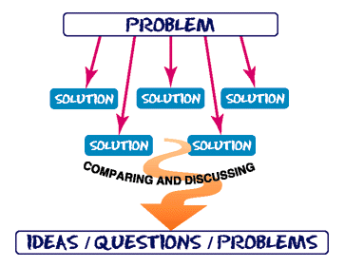
Figure 1: *What is Open Ended Problem Solving??

Lab Task

Task A: [Marks: 40]

Define a class called Fraction. This class is used to represent a ratio of two integers. Include an additional method, equals, that takes as input another Fraction and returns true if the two fractions are identical and false if they are not. Concepts that you should use in your program.

- Menu Driven
- Default & Parameterized constructor for initializing two integers to zero and should be private and accessible through setter/getter methods.
- Overload Stream in and Stream out operator to take input two integers and display their ratio respectively.
- Overload Equal == Operator for finding two fractions identical or not.
(Fraction.h):

#ifndef INC_2022_SPRING_CE_OOP_WEEK11_LABTASK_B_BSCE21017_FRACTION_H
#define INC_2022_SPRING_CE_OOP_WEEK11_LABTASK_B_BSCE21017_FRACTION_H
#include <iostream>
using namespace std;
class Fraction {
private:
int numerator, denominator;
public:
Fraction() {
numerator = 0;
denominator = 0;
}
Fraction(int num, int lower) {
numerator = num;
denominator = lower;
}
void setter(int numerator, int denominator) {
this->numerator = numerator;
this->denominator = denominator;
}
void getter(int &num, int &den) {
den = denominator;
num = numerator;
}
bool equal(Fraction second) {
if (numerator == second.numerator) {
if (denominator == second.denominator) {
return true;
}
}
return false;
}
friend istream &operator>>(istream &os, Fraction &f1) {
cout << "Enter Numerator of the fraction: ";
cin >> f1.numerator;
do {
cout << "Enter Denominator of the fraction: ";
cin >> f1.denominator;
} while (f1.denominator == 0 && cout << "Division by Zero is not allowed, Try again \n");
return os;
}
friend ostream &operator<<(ostream &os, Fraction &f2) {
cout << "Ratio Form: ";
cout << f2.numerator << ":" << f2.denominator << endl;
cout << "Fraction Form: ";
cout << f2.numerator << "/" << f2.denominator << endl;
return os;
}
bool operator==(Fraction second) {
if (numerator == second.numerator) {
if (denominator == second.denominator) {
return true;
}
}
return false;
}
void simplest(int t = 0) {
int rem = 0, rem1 = 0, q1 = 0, q2 = 0, limit = 0, check = 0, act1 = 0, act2 = 0;
if (numerator < denominator) {
limit = numerator;
} else limit = denominator;
for (int i = 2; i < limit + 1; ++i) {
rem = numerator % i;
rem1 = denominator % i;
q1 = numerator / i;
q2 = denominator / i;
// cout << q1 << ":" << q2 << endl;
if (rem == 0 && rem1 == 0) {
if (t == 1)
cout << "Step" << check + 1 << "= "<< q1 << ":" << q2 << endl;
act1 = q1;
act2 = q2;
check++;
}
}
if (check == 0 && t == 1){
cout<<"Already in Simplest Form \n";
}
if (check != 0) {
numerator = act1;
denominator = act2;
}
}
};
#endif //INC_2022_SPRING_CE_OOP_WEEK11_LABTASK_B_BSCE21017_FRACTION_H

(Main Function):

#include <iostream>
#include "Fraction.h"
#include <unistd.h>
using namespace std;
int main() {
system("clear");
int num1, num2, choice;
string rep;
Fraction f2;
cout << "Taking Parameters (of first Fraction) in Main Function: \n";
cout << "Enter Numerator: ";
cin >> num1;
do {
cout << "Enter Denominator: ";
cin >> num2;
} while (num2 == 0 && cout << "Cannot Divide by Zero, Try again \n");
cout << "Passing Parameters to Parameterized Constructor \n";
Fraction f1(num1, num2);
sleep(3);
again:
system("clear");
cout<<"Menu: \n";
cout<<"1. fill the object (of Second Fraction) through input operator overloading \n";
cout<<"2. Simplify and Display the First Fraction \n";
cout<<"3. Simplify and Display the Second Fraction \n";
cout<<"4. Show Steps of Ratio Simplification of First Fraction (Use this before Option 2) \n";
cout<<"5. Show Steps of Ratio Simplification of Second Fraction (Use this before Option 3) \n";
cout<<"6. Check that whether both Fractions are equal through operator overloading \n";
cout<<"7. Check that whether both Fractions are equal through function \n";
cout << "Enter Your choice: ";
cin >> choice;
switch (choice) {
case 1:
cin >> f2;
break;
case 3:
f2.simplest();
cout << f2;
break;
case 2:
f1.simplest();
cout << f1;
break;
case 5:
f2.simplest(1);
break;
case 4:
f1.simplest(1);
break;
case 6:
f1.simplest();
f2.simplest();
if (f2 == f1) {
cout << "Both Fractions are Equal to each other \n";
} else cout << "Not Equal \n";
break;
case 7:
f1.simplest();
f2.simplest();
if (f2.equal(f1)) {
cout << "Both Fractions are Equal to each other \n";
} else cout << "Not Equal \n";
break;
}
cout << "Do you want to use the program again? (Y/N): ";
cin >> rep; //takes input from user
if (rep == "N" or rep == "n" or rep == "no" or rep == "NO" or rep == "No" or rep == "nO") {
return 0; //exits the process with exit code 0
} else goto again; //restart the program flow
}

Output:
Taking Input:
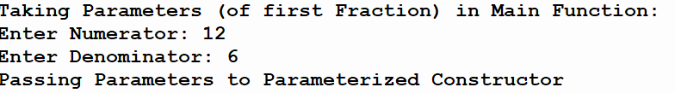
Console sleeps for few seconds….

Taking Input for Second Fraction:
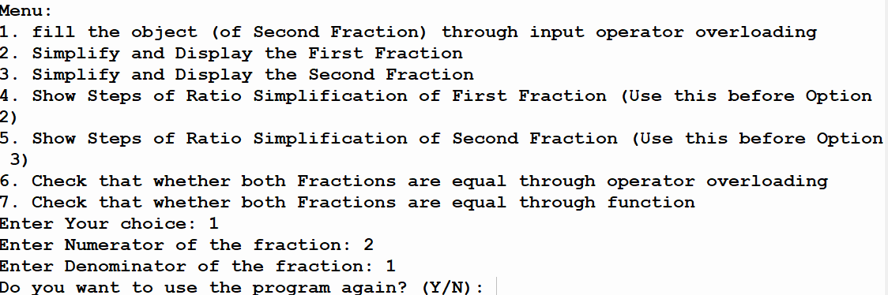

Fraction 1 Simplification with Steps:
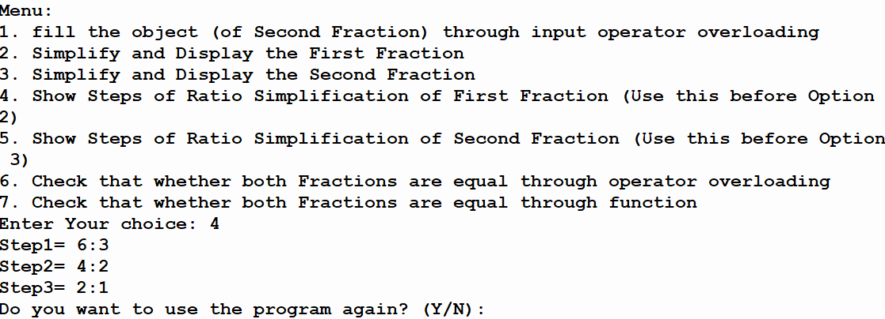

Fraction 2 Display after Simplification (without Steps):
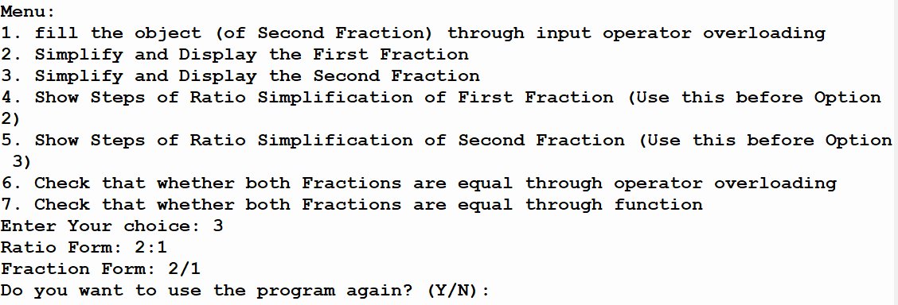

Checking Equality Status of both Fractions by operator overloading:
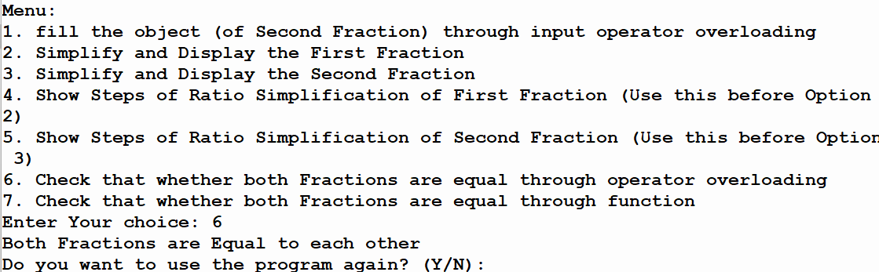

Checking Equality Status of both Fractions by function:
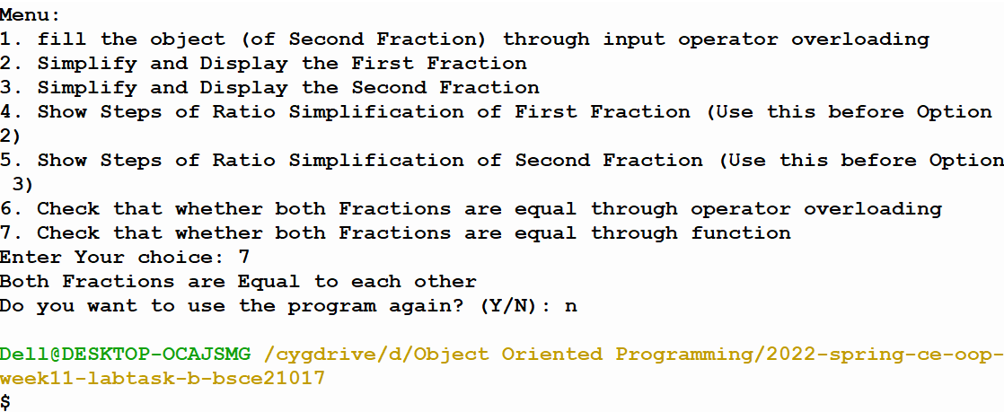

Assessment Rubric for Lab
Method for assessment:

Lab reports and instructor observation during lab sessions. Outcome assessed:
a. Ability to conduct experiments, as well as to analyze and interpret data (P) b. Ability to function on multi-disciplinary teams (A)
c. Ability to use the techniques, skills, and modern engineering tools necessary for engineering practice (P)
Performance metric | Task | CLO | Description | Max marks | Exceeds expectation | Meets expectation | Does not meet expectation | Obtained marks
1. Realization of experiment (a) | 1 | 1 | Functionality | 40 | Executes without errors excellent user prompts, good use of symbols, spacing in output. Through testing has been completed (35-40) | Executes without errors, user prompts are understandable, minimum use of symbols or spacing in output. Some testing has been completed (20-34) | Does not execute due to syntax errors, runtime errors, user prompts are misleading or non-existent. No testing has been completed (0-19)
2. Teamwork (b) | 1 | 3 | Group Performance | 5 | Actively engages and cooperates with other group member(s) in effective manner (4-5) | Cooperates with other group member(s) in a reasonable manner but conduct can be improved (2-3) | Distracts or discourages other group members from conducting the experiment (0-1)
3. Conducting experiment (a, c) | 1 | 1 | On Spot Changes | 10 | Able to make changes (8-10) | Partially able to make changes (5-7) | Unable to make changes (0-4)
 | 1 | 1 | Viva | 10 | Answered all questions (8-10) | Few incorrect answers (5-7) | Unable to answer all questions (0-4)
4. Laboratory safety and disciplinary rules (a) | 1 | 3 | Code commenting | 5 | Comments are added and does help the reader to understand the code (4-5) | Comments are added and does not help the reader to understand the code (2-3) | Comments are not added (0-1)
5. Data collection (c) | 1 | 3 | Code Structure | 5 | Excellent use of white space, creatively organized work, excellent use of variables and constants, correct identifiers for constants, No line-wrap (4-5) | Includes name, and assignment, white space makes the program fairly easy to read. Title, organized work, good use of variables (2-3) | Poor use of white space (indentation, blank lines) making code hard to read, disorganized and messy (0-1)
6. Data analysis (a, c) | 1 | 4 | Algorithm | 20 | Solution is efficient, easy to understand, and maintain (15-20) | A logical solution that is easy to follow but it is not the most efficient (6-14) | A difficult and inefficient solution (0-5)
7. Computer use (c) | 1 | 2 | Documentation & GitHub Submissions | 5 | Timely (4-5) | Late (2-3) | Not done (0-1)
 | Max Marks (total): |  |  | 100 | Obtained Marks (total):

Lab Engineer Signature: ________________________

